**Sustainable Communities**

Student’s Name

University; Department

Course Code: Name of Course

The Professor’s Name

Date of Submission

**Sustainable Communities**

Contents

**1.1 Background** 2

**1.2 Methodology** 3

2.1.2 Data 4

2.1.3 Analysis 5

**2.2 Age Diversity** 6

2.2.1 Theory Overview 6

2.2.2 Present Data and Images 6

2.2.3 Analysis 12

**2.3 Health** 12

2.3.1 Theory Overview 12

2.3.2 Present Data and Images 13

2.3.3 Analysis 14

**2.4 Walkability** 14

2.4.1 Theory Overview 14

2.4.2 Present Data and Images 15

2.4.3 Analysis 21

**2.5 Type of Housing (dwelling structure)** 22

2.5.1 Theory Overview 22

2.5.2 Present Data and Images 22

2.5.3 Analysis 27

**3.0 Challenges that Each Suburb Face** 28

**3.1 Surfers Paradise.** 28

**3.2 Pimpama** 28

**4.0 Recommendations for Each Suburb** 28

**Surfers Paradise** 28

**Pimpama** 29

**5.0** **Bibliography** 30

**1.0 Introduction**

## **1.1 Background**

Urban design significantly influences the overall well-being and quality of life within communities. The configuration of urban areas, residential districts, and communal environments directly influences individuals' engagement with their environment, exerting effects on various aspects ranging from physical well-being to social relationships. Research by the University of Melbourne underscores the imperative of enhancing urban design to foster healthier urban environments. In the precepts, the researchers argue that the accessibility and availability of parks, walkways, and recreational spaces in urban settings promote physical activity, combat obesity, and improve the overall health of residents. A publication by CSIRO underpins the research by presenting the significance of thoughtful urban design in promoting physical activity, psychological well-being, and interpersonal engagement. The authors argue that sufficient green spaces have a positive impact on stress reduction and the promotion of community cohesion. Furthermore, the World Health Organization report highlights the direct impact of urban design on health disparities and environmental sustainability. Implementing inclusive and barrier-free designs plays a crucial role in promoting equitable access for all community members, thereby enhancing both physical and mental health outcomes. Comparing two suburbs in Gold Coast, Australia, Surfers Paradise & Pimpama, the paper deduces the fact that implementing sustainable practices in urban design can mitigate pollution and positively influence air quality. Urban design is crucial in promoting the development of healthier and more dynamic communities through facilitating physical activity, improving mental health, promoting inclusivity, and supporting environmental well-being.

## **1.2 Methodology**

The study focused on collecting a comprehensive database encompassing various aspects such as demographics, indicators of economic growth, and environmental metrics for Surfers Paradise and Pimpama. The study utilized a variety of data sources, including official government records, census data, and locally conducted surveys. Additionally, the research employs different mathematical formulae to compute population growth rates to visualize the changing demographic trends.

**2.0 Sustainable Community Factors**

**2.1 Population Density**

**2**.1.1 Theory Overview

The population density of a region is a quantitative indicator of the human concentration in that region. To achieve sustainability, urban planning must balance overcrowding and under crowding. The equilibrium allows for more effective resource management, the growth of necessary infrastructure, and the enhancement of social conditions. Increases in population density have been shown to affect walkability, public transit, and land use positively. Lower population densities, on the other hand, allow for more open space and less traffic.

### 2.1.2 Data

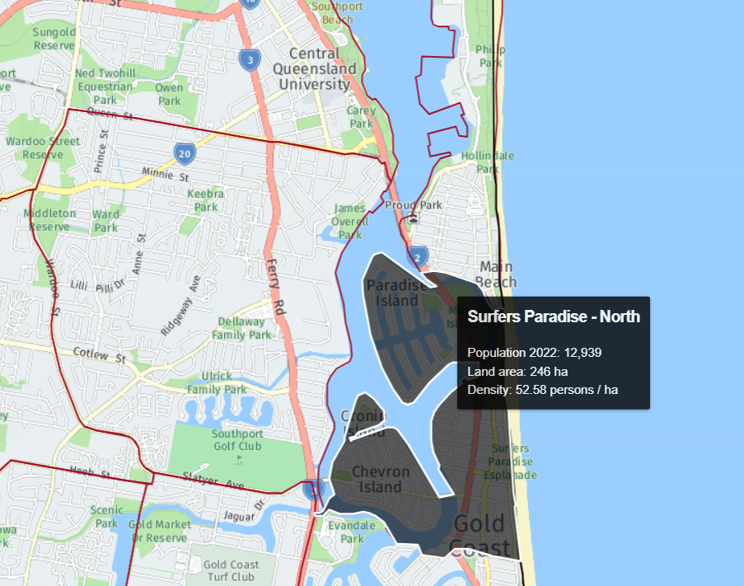

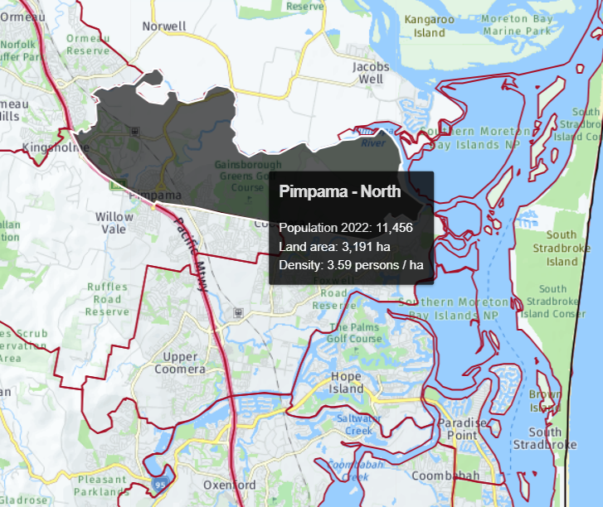

|  |  |  |  |
| --- | --- | --- | --- |
| **Region** | **Population** | **Land Area (ha)** | **Density**  **(persons/ha)** |
| Surfers Paradise North | 12939 | 246 | 52.58 |
| Pimpama North | 11456 | 3191 | 3.59 |

### 2.1.3 Analysis

Surfers Paradise's concentrated urban structure, which serves both residents and visitors, contributes to the area's comparatively high population density. Because of how densely people live there, everything from grocery stores to movie theaters is only a short walk away. Although this strategy may have its advantages, it is not without possible pitfalls, such as the prospect of escalating traffic problems and a depletion of current resources. On the other hand, Pimpama is characterized by a relatively lower population density, making it an attractive choice for families searching for a peaceful suburban environment. While the scenario above may present advantages such as increased availability of expansive natural areas and reduced population density, it may also entail a greater reliance on automobiles and restricted accessibility to specific amenities.

## **2.2 Age Diversity**

### 2.2.1 Theory Overview

Age diversity describes individuals from different age groups in a particular community. Appropriate age diversity promotes social cohesion, encourages interactions between different generations, and facilitates knowledge sharing (Williams, 2017). In other words, a community that has a diverse age structure has the potential to improve its resilience and inclusivity by leveraging the different perspectives and experiences of its members.

### 2.2.2 Present Data and Images

|  |  |  |  |  |  |  |  |
| --- | --- | --- | --- | --- | --- | --- | --- |
| Age structure - Five-year age groups | | | | | | | |
| **Surfers Paradise - North - Total persons (Usual residence)** | **2021** | | | **2016** | | | **Change** |
| **Five-year age groups (years)** | **Number** | **%** | **Gold Coast City %** | **Number** | **%** | **Gold Coast City %** | **2016 to 2021** |
| 0 to 4 | 299 | 2.5 | 5.4 | 286 | 2.6 | 5.9 | +13 |
| 5 to 9 | 244 | 2.0 | 6.0 | 199 | 1.8 | 6.3 | +45 |
| 10 to 14 | 254 | 2.1 | 6.2 | 213 | 1.9 | 5.9 | +41 |
| 15 to 19 | 354 | 2.9 | 5.8 | 418 | 3.8 | 6.1 | -64 |
| 20 to 24 | 898 | 7.4 | 6.3 | 1,267 | 11.4 | 6.7 | -369 |
| 25 to 29 | 1,304 | 10.7 | 6.8 | 1,537 | 13.9 | 6.8 | -233 |
| 30 to 34 | 1,145 | 9.4 | 7.0 | 991 | 8.9 | 6.9 | +154 |
| 35 to 39 | 860 | 7.1 | 7.0 | 687 | 6.2 | 6.7 | +173 |
| 40 to 44 | 654 | 5.4 | 6.6 | 573 | 5.2 | 7.1 | +81 |
| 45 to 49 | 713 | 5.9 | 6.9 | 661 | 6.0 | 7.0 | +52 |
| 50 to 54 | 805 | 6.6 | 6.6 | 705 | 6.4 | 6.5 | +100 |
| 55 to 59 | 852 | 7.0 | 6.1 | 676 | 6.1 | 6.1 | +176 |
| 60 to 64 | 875 | 7.2 | 5.7 | 640 | 5.8 | 5.4 | +235 |
| 65 to 69 | 812 | 6.7 | 5.1 | 741 | 6.7 | 5.4 | +71 |
| 70 to 74 | 840 | 6.9 | 4.9 | 638 | 5.8 | 4.1 | +202 |
| 75 to 79 | 701 | 5.8 | 3.5 | 394 | 3.6 | 2.9 | +307 |
| 80 to 84 | 329 | 2.7 | 2.2 | 258 | 2.3 | 1.9 | +71 |
| 85 and over | 243 | 2.0 | 2.0 | 197 | 1.8 | 2.1 | +46 |
| **Total population** | **12,182** | **100.0** | **100.0** | **11,081** | **100.0** | **100.0** | **+1,101** |

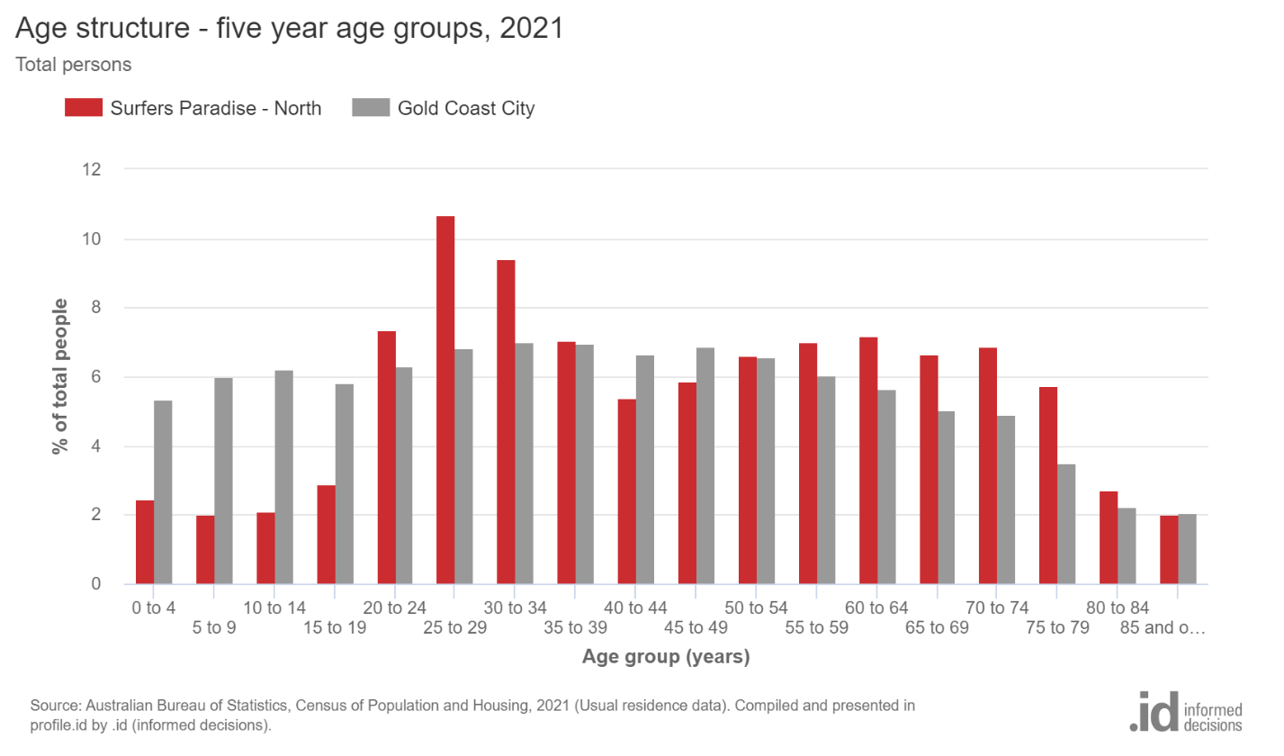

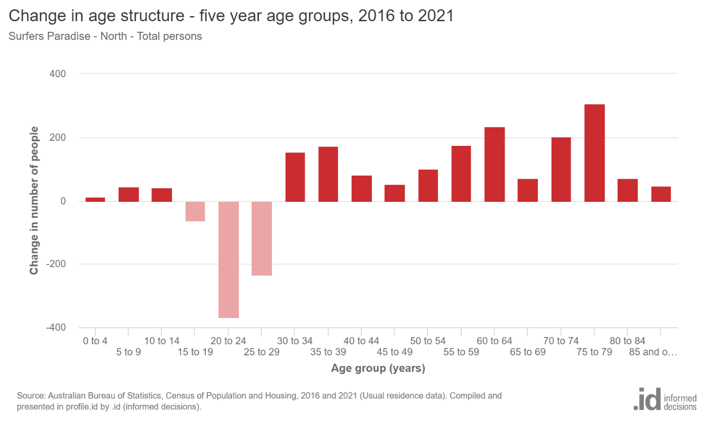

|  |  |  |  |  |  |  |  |
| --- | --- | --- | --- | --- | --- | --- | --- |
| Age structure - Five-year age groups | | | | | | | |
| **Pimpama - North - Total persons (Usual residence)** | **2021** | | | **2016** | | | **Change** |
| **Five-year age groups (years)** | **Number** | **%** | **Gold Coast City %** | **Number** | **%** | **Gold Coast City %** | **2016 to 2021** |
| 0 to 4 | 953 | 9.6 | 5.4 | 351 | 9.9 | 5.9 | +602 |
| 5 to 9 | 852 | 8.6 | 6.0 | 327 | 9.3 | 6.3 | +525 |
| 10 to 14 | 715 | 7.2 | 6.2 | 209 | 5.9 | 5.9 | +506 |
| 15 to 19 | 495 | 5.0 | 5.8 | 212 | 6.0 | 6.1 | +283 |
| 20 to 24 | 588 | 5.9 | 6.3 | 247 | 7.0 | 6.7 | +341 |
| 25 to 29 | 870 | 8.8 | 6.8 | 347 | 9.8 | 6.8 | +523 |
| 30 to 34 | 1,015 | 10.2 | 7.0 | 305 | 8.6 | 6.9 | +710 |
| 35 to 39 | 892 | 9.0 | 7.0 | 261 | 7.4 | 6.7 | +631 |
| 40 to 44 | 631 | 6.4 | 6.6 | 216 | 6.1 | 7.1 | +415 |
| 45 to 49 | 482 | 4.9 | 6.9 | 213 | 6.0 | 7.0 | +269 |
| 50 to 54 | 440 | 4.4 | 6.6 | 190 | 5.4 | 6.5 | +250 |
| 55 to 59 | 338 | 3.4 | 6.1 | 146 | 4.1 | 6.1 | +192 |
| 60 to 64 | 330 | 3.3 | 5.7 | 168 | 4.8 | 5.4 | +162 |
| 65 to 69 | 426 | 4.3 | 5.1 | 120 | 3.4 | 5.4 | +306 |
| 70 to 74 | 400 | 4.0 | 4.9 | 93 | 2.6 | 4.1 | +307 |
| 75 to 79 | 261 | 2.6 | 3.5 | 52 | 1.5 | 2.9 | +209 |
| 80 to 84 | 122 | 1.2 | 2.2 | 36 | 1.0 | 1.9 | +86 |
| 85 and over | 104 | 1.0 | 2.0 | 41 | 1.2 | 2.1 | +63 |
| **Total population** | **9,914** | **100.0** | **100.0** | **3,534** | **100.0** | **100.0** | **+6,380** |

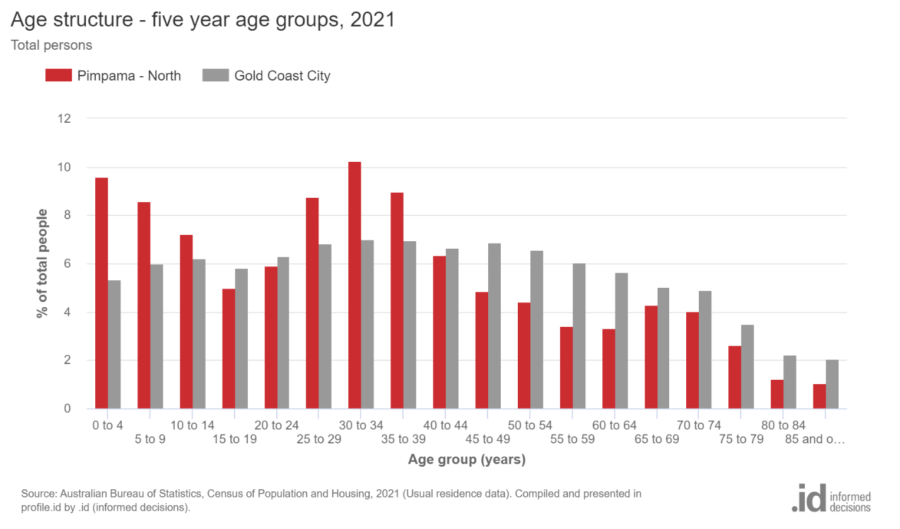

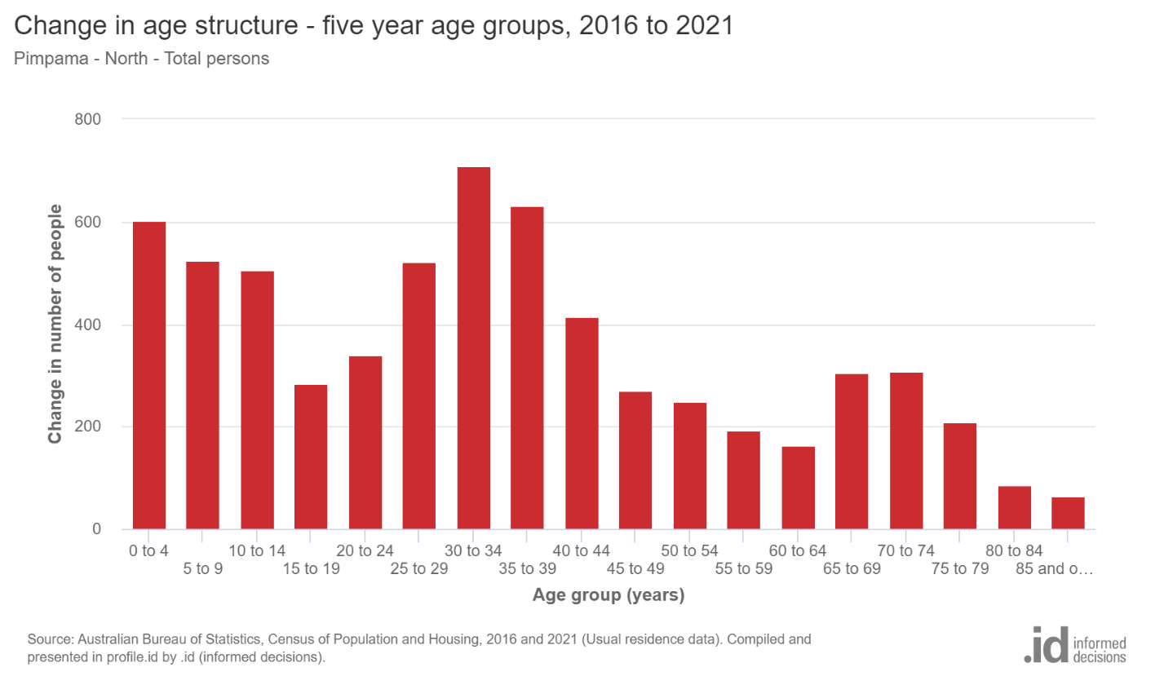

### 2.2.3 Analysis

The age diversity of Surfers Paradise follows its urban dynamics and transient characteristics. Surfers Paradise North exhibits a lower proportion of individuals belonging to the younger age cohorts (below 15 years) and a corresponding high proportion of individuals within the older age cohorts (65 years and above). In general, 6.5% of the total population fell within the age range of 0 to 15 years, while 24.0% were 65 years and above. In contrast, the age diversity in Pimpama is characterized by a strong focus on family-centric values, emphasizing community services, educational institutions, and recreational areas that cater to the needs of various age groups. The demographic composition of Pimpama exhibited a relatively greater representation of individuals in the younger age cohorts (below 15 years) and a comparatively lower representation of individuals in the older age cohorts (65 years and above). In general, 25.4% of the total population fell within the age range of 0 to 15 years, while 13.2% were 65.

## **2.3 Health**

### 2.3.1 Theory Overview

Health plays a crucial role in creating and long-term sustainability of communities. As mentioned, factors such as the provision of healthcare services, availability of green spaces, presence of recreational facilities, and maintenance of clean air positively impact the physical and mental well-being of residents (Wheeler, 2011). Additionally, the presence of aesthetically pleasing and properly maintained environments has been shown to positively impact individuals' mental well-being, reducing stress levels and improving their overall psychological perspective (Australian Institute of Health and Welfare. 2016).

### 2.3.2 Present Data and Images

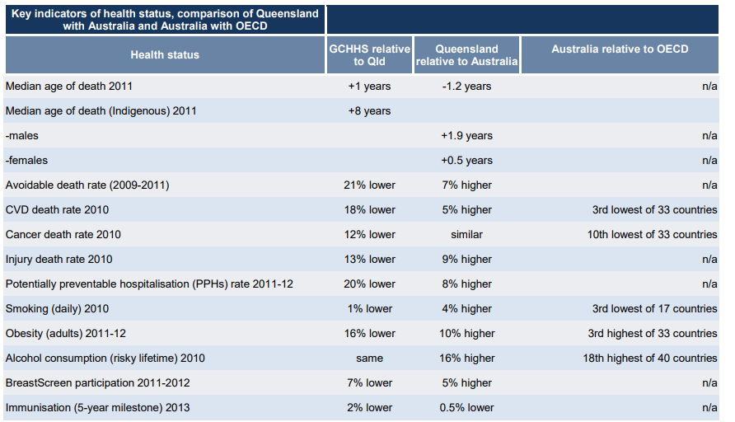

(Queensland Health)

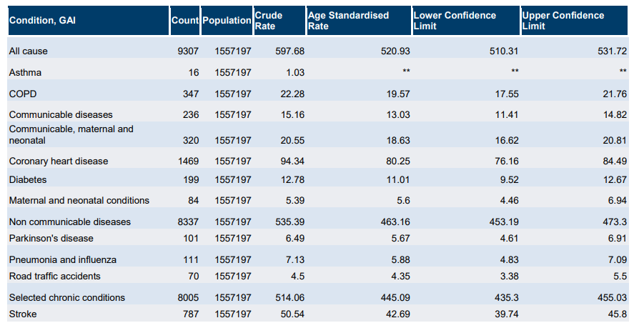

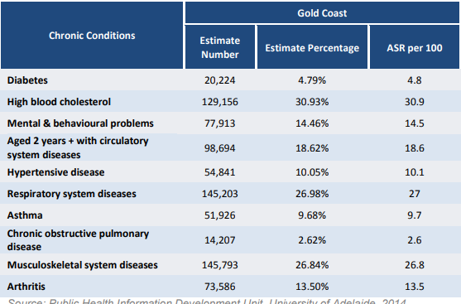

(Queensland Health)

### 2.3.3 Analysis

The health of Surfers Paradise could potentially experience positive effects due to the convenient availability of healthcare services. However, the transient population in this area may present difficulties in ensuring consistent adherence to health-promoting behaviors. The family-oriented atmosphere of Pimpama may catalyze engaging in outdoor activities, thereby potentially enhancing the well-being of its residents. Nevertheless, it is imperative to prioritize healthcare accessibility and the promotion of active lifestyles among individuals of all age groups in suburban areas to enhance their overall sustainability in terms of health.

## **2.4 Walkability**

### 2.4.1 Theory Overview

Walkability pertains to the convenience and accessibility of pedestrian facilities in a specific community. Indeed, a walkable environment offers numerous benefits, including decreasing reliance on cars, promoting higher levels of physical activity, and fostering community interactions (Frost, 2018; Price, 2017; Schaefer, 2005).

### 2.4.2 Present Data and Images

|  |  |
| --- | --- |
| **Region** | **Walk Score** |
| Surfers Paradise | 78 |
| Pimpama | 13 |

|  |  |  |  |  |  |  |  |
| --- | --- | --- | --- | --- | --- | --- | --- |
| Car ownership | | | | | | | |
| **Pimpama - North - Households (Enumerated)** | **2021** | | | **2016** | | | **Change** |
| **Number of cars** | **Number** | **%** | **Parkwood %** | **Number** | **%** | **Parkwood %** | **2016 to 2021** |
| No motor vehicles | 59 | 1.8 | 2.7 | 10 | 0.9 | 2.4 | +49 |
| 1 motor vehicle | 989 | 29.8 | 21.6 | 252 | 22.0 | 22.2 | +737 |
| 2 motor vehicles | 1,480 | 44.6 | 41.5 | 472 | 41.3 | 41.3 | +1,008 |
| 3 or more motor vehicles | 638 | 19.2 | 29.4 | 254 | 22.2 | 26.8 | +384 |
| Not stated | 154 | 4.6 | 4.7 | 156 | 13.6 | 7.3 | -2 |
| **Total households** | **3,320** | **100.0** | **100.0** | **1,144** | **100.0** | **100.0** | **+2,176** |

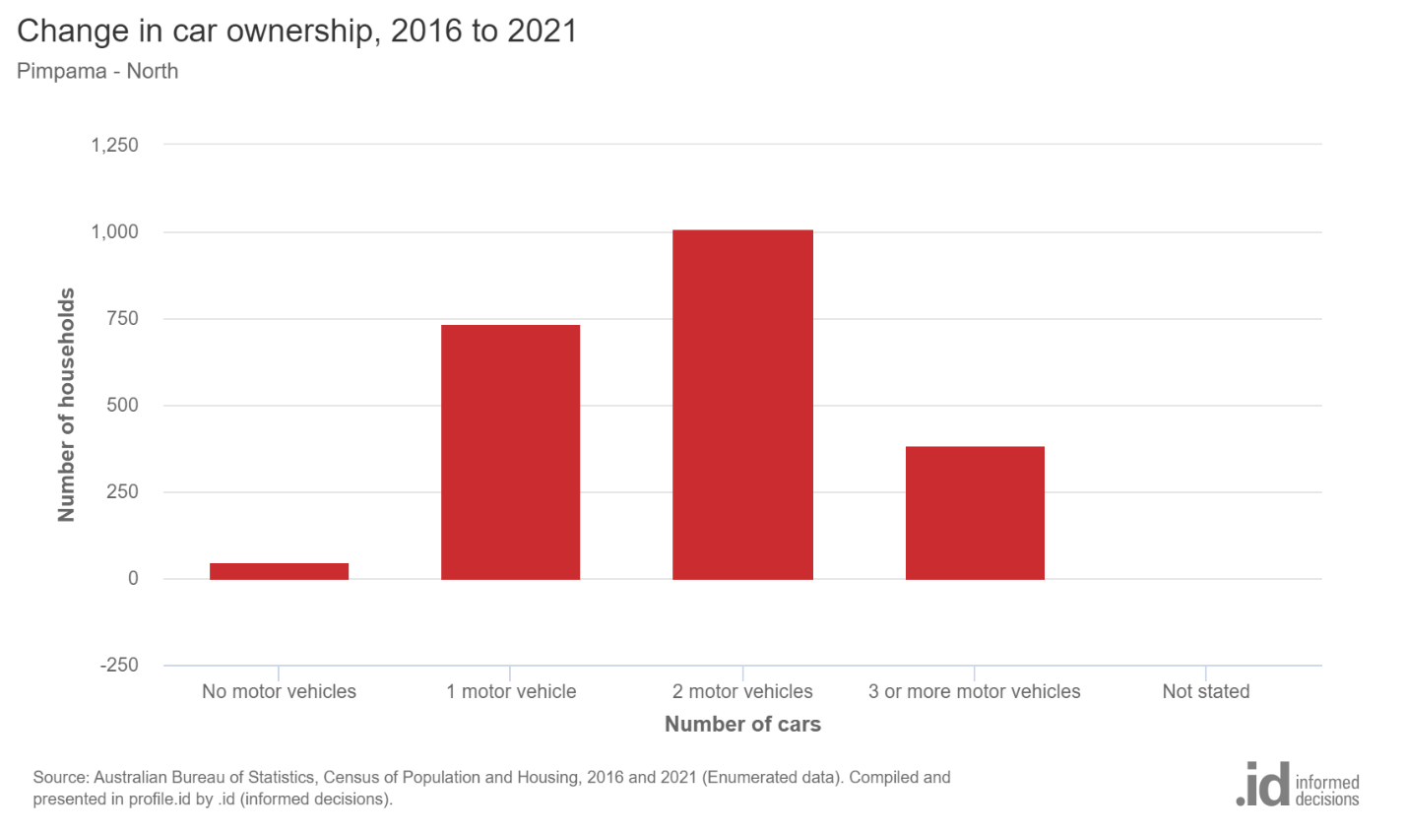

|  |  |  |  |  |  |  |  |
| --- | --- | --- | --- | --- | --- | --- | --- |
| **Car ownership** | | | | | | | |
| **Surfers Paradise - North - Households (Enumerated)** | **2021** | | | **2016** | | | **Change** |
| **Number of cars** | **Number** | **%** | **Parkwood %** | **Number** | **%** | **Parkwood %** | **2016 to 2021** |
| No motor vehicles | 755 | 12.0 | 2.7 | 703 | 12.9 | 2.4 | +52 |
| 1 motor vehicle | 3,160 | 50.2 | 21.6 | 2,457 | 45.1 | 22.2 | +703 |
| 2 motor vehicles | 1,285 | 20.4 | 41.5 | 1,093 | 20.1 | 41.3 | +192 |
| 3 or more motor vehicles | 416 | 6.6 | 29.4 | 317 | 5.8 | 26.8 | +99 |
| Not stated | 684 | 10.9 | 4.7 | 879 | 16.1 | 7.3 | -195 |
| **Total households** | **6,300** | **100.0** | **100.0** | **5,449** | **100.0** | **100.0** | **+851** |

|  |  |  |  |  |  |  |  |
| --- | --- | --- | --- | --- | --- | --- | --- |
| Method of travel to work | | | | | | | |
| **Pimpama - North - Employed persons (Usual residence)** | **2021** | | | **2016** | | | **Change** |
| **Main method of travel** | **Number** | **%** | **Gold Coast City %** | **Number** | **%** | **Gold Coast City %** | **2016 to 2021** |
| Train | 89 | 2.0 | 1.1 | 54 | 3.6 | 1.8 | +35 |
| Bus | 20 | 0.4 | 1.0 | 16 | 1.1 | 1.6 | +4 |
| Tram | 0 |  | 0.5 | 0 |  | 0.6 | 0 |
| Ferry | 0 |  | 0.0 | 0 |  | 0.0 | 0 |
| Taxi/ride-share | 7 | 0.2 | 0.2 | 0 |  | 0.1 | +7 |
| Car - as driver | 3,000 | 65.9 | 62.9 | 1,055 | 70.0 | 68.9 | +1,945 |
| Car - as passenger | 167 | 3.7 | 3.9 | 78 | 5.2 | 4.8 | +89 |
| Truck | 41 | 0.9 | 0.7 | 17 | 1.1 | 0.8 | +24 |
| Motorbike | 20 | 0.4 | 0.6 | 12 | 0.8 | 0.8 | +8 |
| Bicycle | 3 | 0.1 | 0.7 | 0 |  | 0.8 | +3 |
| Walked only | 34 | 0.7 | 2.0 | 12 | 0.8 | 2.6 | +22 |
| Other | 64 | 1.4 | 1.3 | 18 | 1.2 | 1.5 | +46 |
| Worked at home | 583 | 12.8 | 13.8 | 83 | 5.5 | 5.9 | +500 |
| Did not go to work | 493 | 10.8 | 10.9 | 160 | 10.6 | 8.9 | +333 |
| Not stated | 32 | 0.7 | 0.5 | 3 | 0.2 | 0.8 | +29 |
| **Total employed persons aged 15+** | **4,553** | **100.0** | **100.0** | **1,508** | **100.0** | **100.0** | **+3,045** |

(Demographic resources)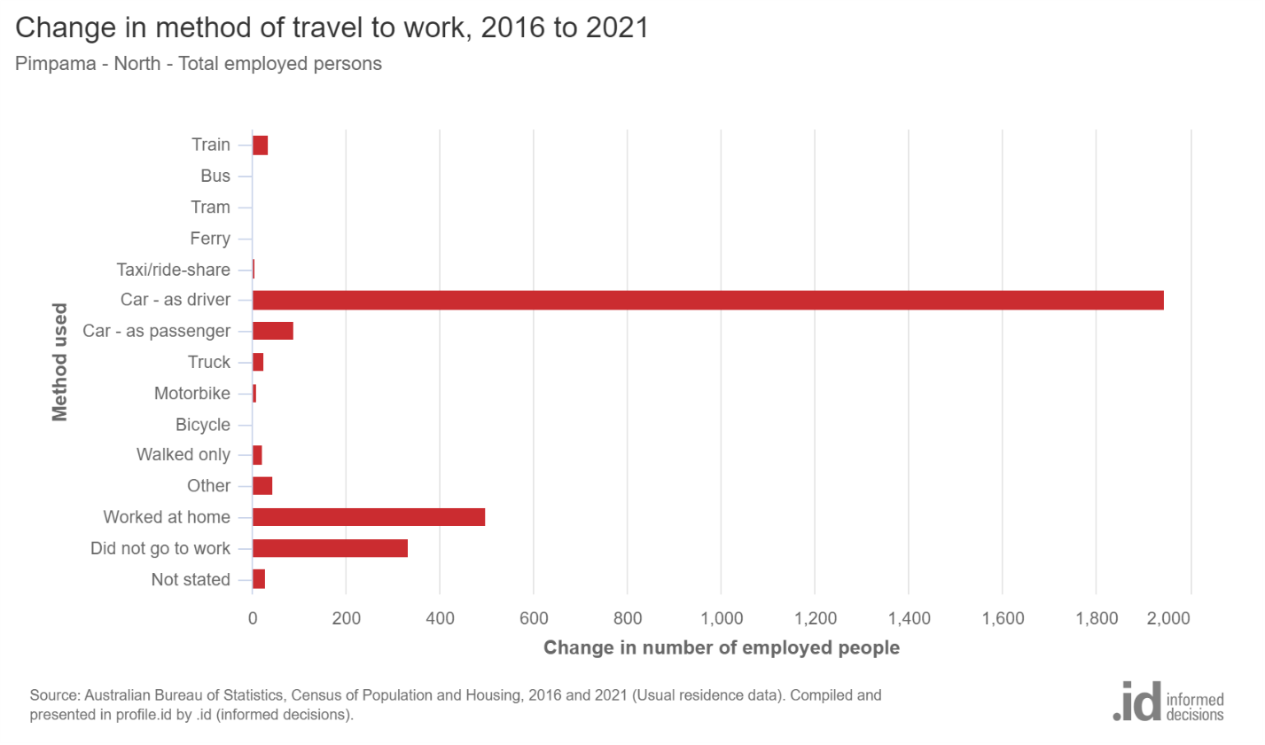

|  |  |  |  |  |  |  |  |
| --- | --- | --- | --- | --- | --- | --- | --- |
| Method of travel to work | | | | | | | |
| **Surfers Paradise - North - Employed persons (Usual residence)** | **2021** | | | **2016** | | | **Change** |
| **Main method of travel** | **Number** | **%** | **Gold Coast City %** | **Number** | **%** | **Gold Coast City %** | **2016 to 2021** |
| Train | 88 | 1.5 | 1.1 | 134 | 2.6 | 1.8 | -46 |
| Bus | 152 | 2.6 | 1.0 | 168 | 3.2 | 1.6 | -16 |
| Tram | 212 | 3.6 | 0.5 | 270 | 5.2 | 0.6 | -58 |
| Ferry | 3 | 0.1 | 0.0 | 3 | 0.1 | 0.0 | 0 |
| Taxi/ride-share | 18 | 0.3 | 0.2 | 14 | 0.3 | 0.1 | +4 |
| Car - as driver | 2,811 | 48.4 | 62.9 | 2,524 | 48.7 | 68.9 | +287 |
| Car - as passenger | 209 | 3.6 | 3.9 | 194 | 3.7 | 4.8 | +15 |
| Truck | 13 | 0.2 | 0.7 | 17 | 0.3 | 0.8 | -4 |
| Motorbike | 40 | 0.7 | 0.6 | 51 | 1.0 | 0.8 | -11 |
| Bicycle | 70 | 1.2 | 0.7 | 84 | 1.6 | 0.8 | -14 |
| Walked only | 598 | 10.3 | 2.0 | 763 | 14.7 | 2.6 | -165 |
| Other | 85 | 1.5 | 1.3 | 90 | 1.7 | 1.5 | -5 |
| Worked at home | 864 | 14.9 | 13.8 | 333 | 6.4 | 5.9 | +531 |
| Did not go to work | 613 | 10.6 | 10.9 | 488 | 9.4 | 8.9 | +125 |
| Not stated | 34 | 0.6 | 0.5 | 46 | 0.9 | 0.8 | -12 |
| **Total employed persons aged 15+** | **5,810** | **100.0** | **100.0** | **5,179** | **100.0** | **100.0** | **+631** |

(Demographic resources)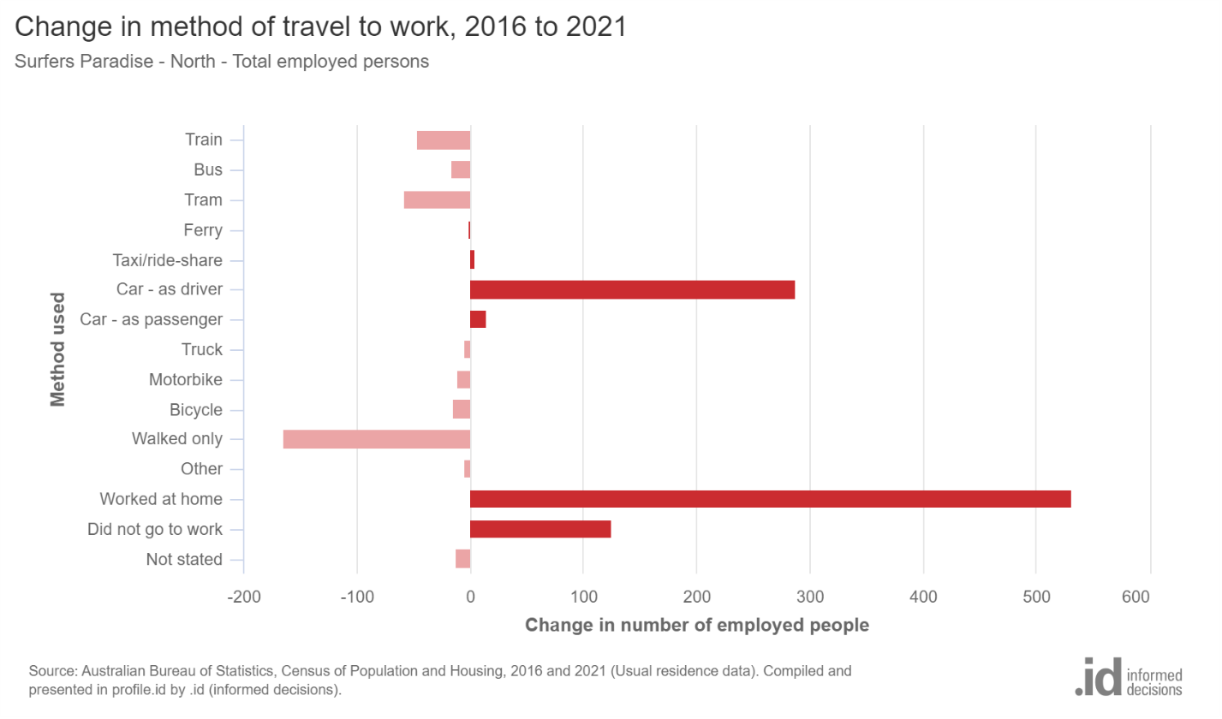 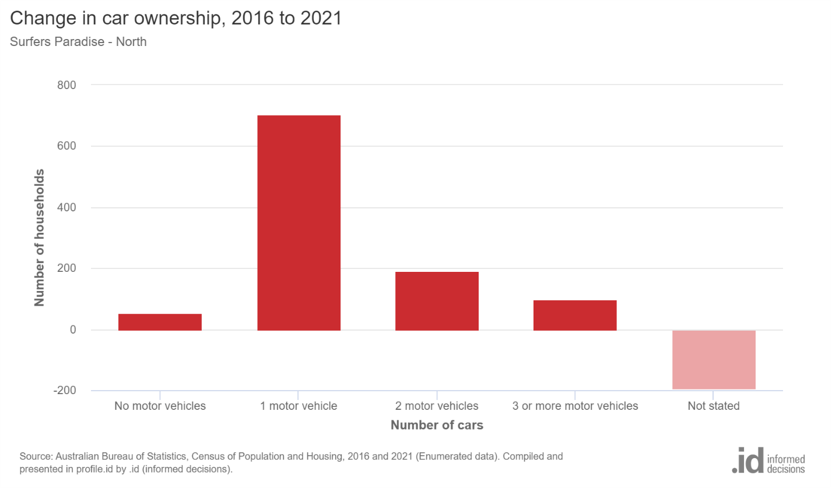

### 2.4.3 Analysis

Surfers Paradise is a very walkable community. It is ranked as the second most walkable area. Most errands in the region can be accomplished by foot due to its proximity to various amenities. On the other hand, Pimpama is a car-oriented region. Pimpama ranks as the 52nd most walkable neighborhood in the Gold Coast region, as determined by its Walk Score 13. The majority of errands in the Pimpama area of the Gold Coast necessitate the use of an automobile. The suburban design of Pimpama has the potential to foster a reliance on automobiles, which could have implications for the physical activity levels of its residents.

## **2.5 Type of Housing (dwelling structure)**

### 2.5.1 Theory Overview

Housing diversity encompasses a broad spectrum of residential structures designed to cater to different households' diverse requirements and dimensions. The presence of diverse housing options plays a significant role in fostering social inclusivity and enhancing the vibrancy of neighborhoods (Kleeman et al.).

### 2.5.2 Present Data and Images

|  |  |  |  |  |  |  |  |
| --- | --- | --- | --- | --- | --- | --- | --- |
| Dwelling type | | | | | | | |
| **Surfers Paradise - North** | **2021** | | | **2016** | | | **Change** |
| **Dwelling type** | **Number** | **%** | **Gold Coast City %** | **Number** | **%** | **Gold Coast City %** | **2016 to 2021** |
| Occupied private dwellings | 6,299 | 68.4 | 89.9 | 5,505 | 74.9 | 90.0 | +794 |
| Unoccupied private dwellings | 2,857 | 31.0 | 9.9 | 1,790 | 24.4 | 9.7 | +1,067 |
| Non private dwellings | 56 | 0.6 | 0.2 | 53 | 0.7 | 0.2 | +3 |
| **Total dwellings** | **9,212** | **100.0** | **100.0** | **7,348** | **100.0** | **100.0** | **+1,864** |
| **Dwelling structure** | | | | | | | |
| **Surfers Paradise - North - Dwellings (Enumerated)** | **2021** | | | **2016** | | | **Change** |
| **Dwelling type** | **Number** | **%** | **Gold Coast City %** | **Number** | **%** | **Gold Coast City %** | **2016 to 2021** |
| Separate house | 553 | 6.0 | 52.4 | 578 | 8.0 | 54.5 | -25 |
| Medium density | 855 | 9.3 | 24.1 | 847 | 11.7 | 24.6 | +8 |
| High density | 7,556 | 82.6 | 22.3 | 5,805 | 79.8 | 19.1 | +1,751 |
| Caravans, cabin, houseboat | 0 |  | 0.7 | 0 |  | 1.2 | 0 |
| Other | 121 | 1.3 | 0.2 | 17 | 0.2 | 0.2 | +104 |
| Not stated | 61 | 0.7 | 0.3 | 23 | 0.3 | 0.5 | +38 |
| **Total Private Dwellings** | **9,146** | **100.0** | **100.0** | **7,270** | **100.0** | **100.0** | **+1,876** |

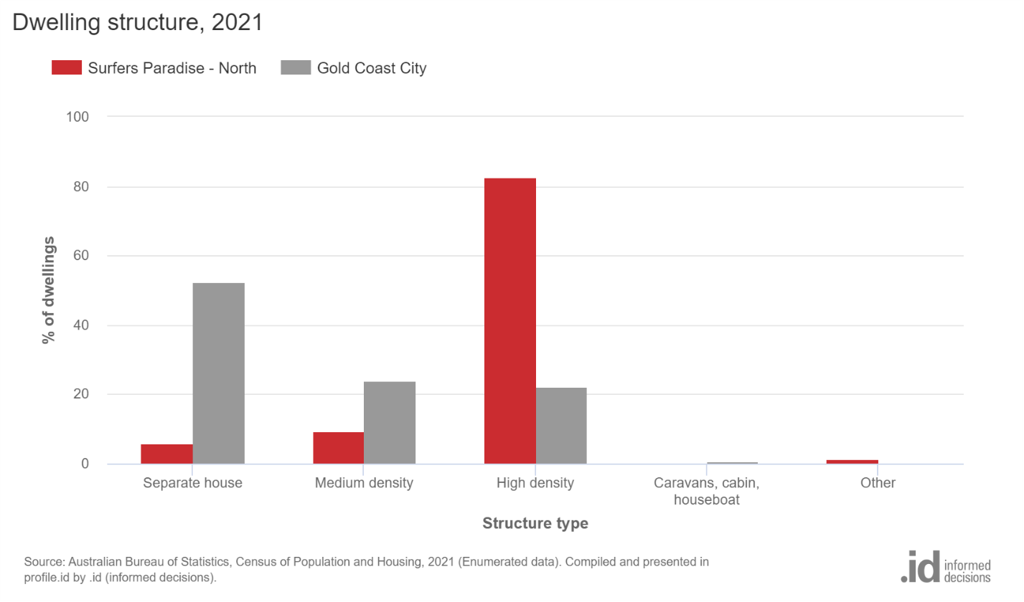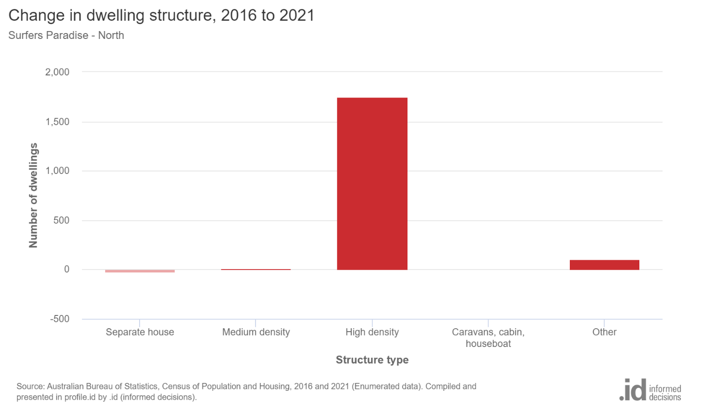

|  |  |  |  |  |  |  |  |
| --- | --- | --- | --- | --- | --- | --- | --- |
| Dwelling structure | | | | | | | |
| **Pimpama - North - Dwellings (Enumerated)** | **2021** | | | **2016** | | | **Change** |
| **Dwelling type** | **Number** | **%** | **Gold Coast City %** | **Number** | **%** | **Gold Coast City %** | **2016 to 2021** |
| Separate house | 2,732 | 79.3 | 52.4 | 939 | 80.3 | 54.5 | +1,793 |
| Medium density | 708 | 20.5 | 24.1 | 230 | 19.7 | 24.6 | +478 |
| High density | 0 |  | 22.3 | 0 |  | 19.1 | 0 |
| Caravans, cabin, houseboat | 0 |  | 0.7 | 0 |  | 1.2 | 0 |
| Other | 0 |  | 0.2 | 0 |  | 0.2 | 0 |
| Not stated | 6 | 0.2 | 0.3 | 0 |  | 0.5 | +6 |
| **Total Private Dwellings** | **3,446** | **100.0** | **100.0** | **1,169** | **100.0** | **100.0** | **+2,277** |
| **Dwelling type** | | | | | | | |
| **Pimpama - North** | **2021** | | | **2016** | | | **Change** |
| **Dwelling type** | **Number** | **%** | **Gold Coast City %** | **Number** | **%** | **Gold Coast City %** | **2016 to 2021** |
| Occupied private dwellings | 3,318 | 96.1 | 89.9 | 1,136 | 97.2 | 90.0 | +2,182 |
| Unoccupied private dwellings | 136 | 3.9 | 9.9 | 33 | 2.8 | 9.7 | +103 |
| Non private dwellings | 0 |  | 0.2 | 0 |  | 0.2 | 0 |
| **Total dwellings** | **3,454** | **100.0** | **100.0** | **1,169** | **100.0** | **100.0** | **+2,285** |

(Demographic resources)

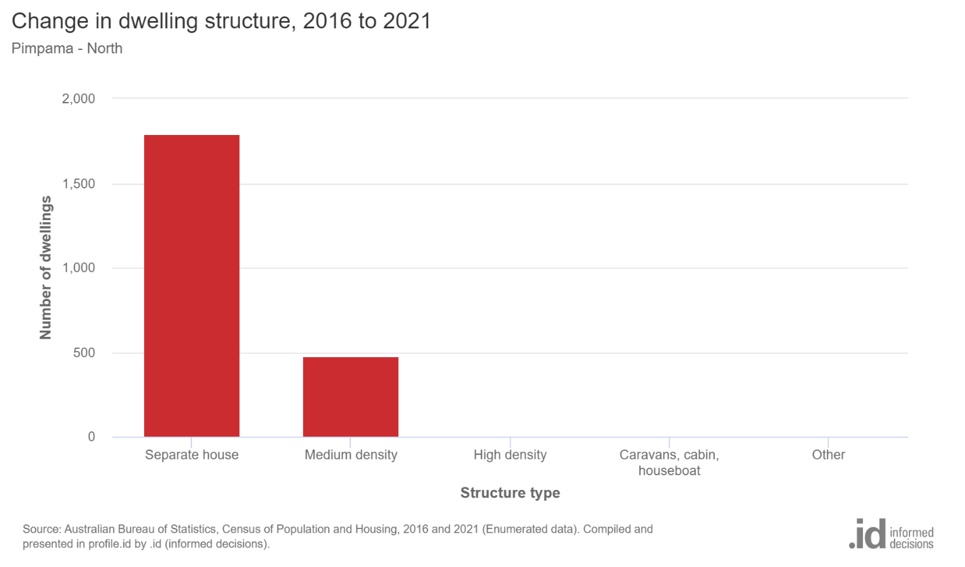

(Demographic resources)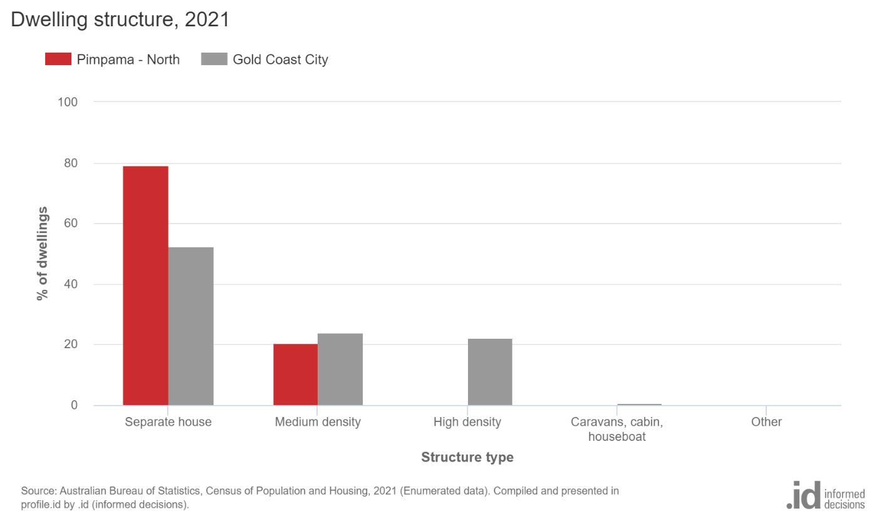

### 2.5.3 Analysis

Surfers Paradise, noted for its high-density residential development, is anticipated to offer many housing choices. However, it may encounter difficulties in catering to the needs of larger households. The family-centric atmosphere of Pimpama may contribute to the prevalence of single-family residences. Nevertheless, there is potential for enhancing the housing landscape by incorporating a wider range of options to accommodate a more diverse demographic. The enhancement of housing diversity in suburban areas can be achieved by promoting mixed-use developments, implementing accessory dwelling units, and providing affordable housing options. These measures contribute to the creation of sustainable and inclusive communities.

# **3.0 Challenges that Each Suburb Face**

## **3.1 Surfers Paradise.**

Surfers Paradise exhibits a transient community characterized by a high turnover of tourists, which may impede the establishment of a robust sense of community and enduring social connections. Besides, the high population density in the region perpetuates a strain on infrastructure, resulting in challenges such as traffic congestion and overcrowding in public areas. Finally, the heavy tourism industry can contribute to heightened waste generation, housing costs, and carbon emissions.

## **3.2 Pimpama**

The expansion of Pimpama may surpass the progress of necessary services and amenities, leading to difficulties in adequately catering to the diverse age demographic. Concerning car dependency, suburban areas' spatial arrangement may foster reliance on automobiles, resulting in heightened traffic congestion, air pollution, and diminished opportunities for pedestrian mobility. Lastly, Pimpama exhibits high community fragmentation characterized by the presence of diverse age groups, which can potentially result in social isolation.

# **4.0 Recommendations for Each Suburb**

## **Surfers Paradise**

1. Promote initiatives to foster connections between tourists and permanent residents to cultivate a more robust sense of community engagement.
2. Adopting sustainable tourism practices entails the implementation of policies aimed at effectively managing the environmental impact of tourism activities. These policies encompass various strategies, such as waste management and carbon reduction, designed to mitigate tourism's negative effects on the environment.
3. The proposed solution entails investing in transportation and public space enhancements to address the challenges posed by a high population density and alleviate traffic congestion.
4. Promote Economic Diversification: Foster the expansion of industries beyond the tourism sector to enhance employment stability for local inhabitants.

## **Pimpama**

1. The objective of comprehensive planning is to formulate a master plan that effectively facilitates the timely provision of essential services and amenities to accommodate the increasing population growth.
2. Promoting walkable neighborhoods entails prioritizing the development of pedestrian-friendly infrastructure, such as sidewalks and cycling lanes, to diminish reliance on automobiles and foster active lifestyles.
3. Intergenerational programs promote community cohesion by facilitating activities that foster interactions among individuals from diverse age groups.
4. Sustainable growth entails striking a harmonious equilibrium between urban development and preserving green spaces and open areas, safeguarding suburban regions' inherent natural charm while addressing the infrastructure requirements.
5. By acknowledging and tackling these obstacles and adopting the suggested approaches, the Gold Coast City Council can strive towards fostering greater sustainability and resilience within Surfers Paradise and Pimpama communities.

# **5.0 Bibliography**

Kleeman, A., Gunn, L., & Giles-Corti., B. (n.d.). Housing diversity. heart foundation. <https://www.healthyactivebydesign.com.au/design-features/housing-diversity>

Wheeler, A. (2011). Planning for Urban Health: An Analysis of Metropolitan Strategic Planning in Australia. University of New South Wales. <https://courses.ssc.qld.edu.au/content/enforced/14747-11GEO0/Topic%203%20Files/Healthy_Metro_Planning_in_Australia.pdf?_&d2lSessionVal=bDsLv3qGLQ81CSlkSBlQCHiKY&ou=14747>

Australian Institute of Health and Welfare. (2016). Australia’s health 2016. <https://www.aihw.gov.au/getmedia/ca0b4c1b-a675-472e-942d-06774c058d27/AH16-1-1-what-is-health.pdf.aspx>

Queensland Health. The health of Queenslanders 2018. Report of the Chief Health Officer Queensland. Queensland Government. Brisbane 2018

Demographic resources. (n.d.). .id (informed decisions). <https://home.id.com.au/demographic-resources>

Schaefer, A. (2005, October 1). Commuting takes its toll. Scientific American. <https://www.scientificamerican.com/article/commuting-takes-its-toll/>

Williams. (2017, January 30). Age diversity for social cohesion. Child in the City. <https://www.childinthecity.org/2017/01/30/age-diversity-for-social-cohesion/?gdpr=accept>

Price, A. (2017, December 14). The negative consequences of car dependency. Strong Towns. <https://www.strongtowns.org/journal/2017/11/2/the-negative-consequences-of-car-dependency>

Frost, N. (2018, October 13). For the good of all, make your city more walkable. Quartz. <https://qz.com/1421323/for-the-good-of-all-humankind-make-your-city-more-walkable>